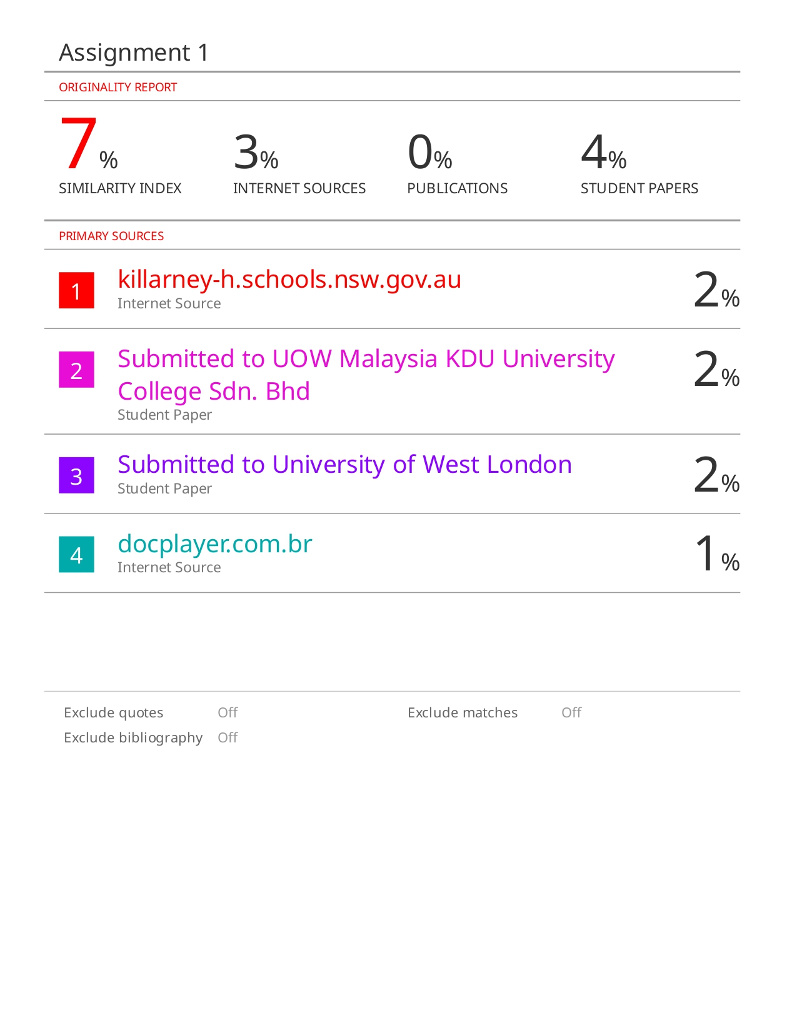

Table of Contents

1.0 Program Listing 3

1.1 Task 1(a) 3

1.2 Task 1(b) 3

1.3 Task 2 4

2.0 Screenshots and Test Cases 5

2.1 Task 1(a) 5

2.2 Task 1(b) 6

2.3 Task 2 8

2.3.1 Successful Case 8

2.3.2 Unsuccessful Case - Business Rule #1 Violated [Term Format] 9

2.3.3 Unsuccessful Case - Business Rule #2 Violated [Grades Value] 10

2.3.4 Unsuccessful Case – Duplicated Record 11

3.0 Listing of All PL/SQL Statements Processed 12

3.1 Task 1(a) 12

3.2 Task 1(b) 13

3.3 Task 2 14

3.4 Screenshots and Test Cases 15

4.0 Reference List 19

# 1.0 Program Listing

## 1.1 Task 1(a)

*Figure 1.1* Source Code of Task1 (a)

## 1.2 Task 1(b)

*Figure 1.2* Source Code of Task1 (b)

## 1.3 Task 2

*Figure 1.4* Source Code of Task2

# 2.0 Screenshots and Test Cases

## 2.1 Task 1(a)



*Figure 2.1* All Components Record

|  |  |  |
| --- | --- | --- |
|  | **Input** | **Expected Outcome** |
| Term | f96 | Only record 3, record 4, record 6 will be selected along with the subject no, capitalised subject title, expanded term, component name with first letter capitalised, maxpoints and weight. |
| Minimum Weight | 40 |

*Table 1.1* Test Case for Task 1(a)

According to *Figure 2.1*, listing out all of the record in components, it is expected that only record 3, record 4 and record 6 will be selected as the output of the query when user key in f96 as term and 40 as minimum weight. The reason is that, records other than having term of f96 and weight greater or equal to 40 should be filtered out.



*Figure 2.2* Output of Test Case

*Figure 2.2* shows that the program works perfectly which its output is same as the expected outcome of the test case in *Table 1.1*.

## 2.2 Task 1(b)

The course average is the sum of the weighted averages of the individual component scores. According to (Mamalat, 2020), the formula of weighted average is defined by divide the sum of the products of points with its corresponded weight by the total of the weights as shown in *Figure 2.3*.

*Figure 2.3* Formula of Weighted Average and Example of Calculation

However, due to the reason that, some of the components having maximum marks that are greater than 100 or not equal to 100, for example, programs with the maxpoints of 400, and quizzes with the maxpoints of 80 as shown in *Figure 2.4*.

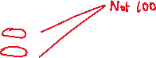

*Figure 2.4* Components Maxpoints not 100 for All Components

Hence, when applying the formula for weighted average, one more value has to be considered, which is its maxpoints. Hence, the formula used in this program is shown in *Figure 2.5*.

*Figure 2.5* Formula Used in Program Calculating Weighted Average with Example

Hence, using this formula, the expected course average for the records selected in *Table 1.2* test case is shown in *Figure 2.6*.

*Figure 2.6* Expected Course Average for Selected Records

|  |  |  |
| --- | --- | --- |
|  | **Input** | **Expected Outcome** |
| Term | f96 | Only select record with the term of f96, and lineno of 1031. Display the query result with the term, lineno, student ID, last name, first name and course average. |
| Line No | 1031 |

*Table 1.2* Test Case for Task 1(b)

Hence, based on the output in *Figure 2.7*, it is clear that the program executed well without any mistake as it is same as the expected outcome as stated in *Table 1.2* test case.



*Figure 2.7* Output of Test Case

## 2.3 Task 2

### 2.3.1 Successful Case

*Figure 2.8* shows the initial records in courses table.

*Figure 2.8* Initial Records in Courses Table

*Figure 2.9* shows that after compiled the file for procedure and run the script for prompting user input, then, enter all valid input, it shows that the new record is added to the courses table which indicates the program runs well as expected corresponding to the test case *Table* *1.3*.

|  |  |  |
| --- | --- | --- |
|  | **Input** | **Expected Outcome** |
| Term | f01 | New record added to the courses table with correct details entered. |
| Line No | 1031 |
| Subject No | csc481 |
| Grade A | 80 |
| Grade B | 70 |
| Grade C | 60 |
| Grade D | 45 |

*Table 1.3* Test Case for Task 2 – Successful Case



*Figure 2.9* Output of Test Case

### 2.3.2 Unsuccessful Case - Business Rule #1 Violated [Term Format]

As stated in the assignment instructions, the first business rule of the program is that the format of term should be started with the character either ‘f’ (Fall), ‘sp’ (Spring) or ‘s’ (Summer) and followed by 2 digits to indicate year (Eg:sp97). Hence, the expected outcome is shown in test case *Table 1.4*. Note that slash (/) indicates the input for second test.

|  |  |  |
| --- | --- | --- |
|  | **Input** | **Expected Outcome** |
| Term | a22 / f999 | Record is not added and prompt out the error message with error code. |
| Line No | 1031 |
| Subject No | csc227 |
| Grade A | 90 |
| Grade B | 80 |
| Grade C | 70 |
| Grade D | 60 |

*Table 1.4* Test Case for Task 2 – Unsuccessful Case [Business Rule #1 Violated]

*Figure 2.10* and *Figure 2.11* show that the program can capture the action of user violating the business rule and prompt the error message with error code. The result has not been added to the courses table as shown in *Figure 2.12*.



|  |  |
| --- | --- |
|  |  |
| *Figure 2.10* Output of Test Case – Invalid Character for Term | *Figure 2.11* Output of Test Case – Invalid Digits for Term |



*Figure 2.12* Result is Not Added

### 2.3.3 Unsuccessful Case - Business Rule #2 Violated [Grades Value]

As stated in the assignment instructions, the second business rule of the program is that the grades value should be in the range of 0-100 and the higher-grade value should be larger than the subsequent lower grade at least 10 points (A:90, B:80, C:70, D:60). Hence, the expected outcome is shown in test case *Table 1.5*. Note that slash (/) indicates the input for second test.

|  |  |  |
| --- | --- | --- |
|  | **Input** | **Expected Outcome** |
| Term | f23 | Record is not added and prompt out the error message with error code. |
| Line No | 1031 |
| Subject No | csc227 |
| Grade A | 90 / -1 |
| Grade B | 85 |
| Grade C | 84 |
| Grade D | 70 |

*Table 1.5* Test Case for Task 2 – Unsuccessful Case [Business Rule #2 Violated]

*Figure 2.13* and *Figure 2.14* show that the program can capture the action of user violating the business rule and prompt the error message with error code. The result has not been added to the courses table as shown in *Figure 2.15*.



|  |  |
| --- | --- |
|  |  |
| *Figure 2.13* Output of Test Case – The Higher Grade is Not At Least 10 Points Greater Than Subsequent Lower Grade | *Figure 2.14* Output of Test Case – Grade Value Not in The Range of 0-100 |

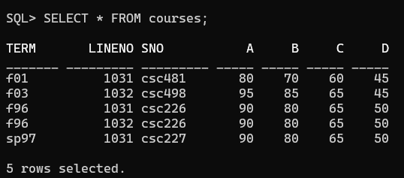



*Figure 2.15* Result is Not Added

### 2.3.4 Unsuccessful Case – Duplicated Record

In order to ensure the database integrity, it is necessary to ensure that there is no duplicated data or record. Hence, test case *Table 1.6* shows the expected outcome when user entered duplicated data on the term and lineno, which act as the primary key and having the unique constraint.

|  |  |  |
| --- | --- | --- |
|  | **Input** | **Expected Outcome** |
| Term | sp97 | Record is not added and prompt out the error message with error code. |
| Line No | 1031 |
| Subject No | csc498 |
| Grade A | 90 |
| Grade B | 80 |
| Grade C | 70 |
| Grade D | 60 |

*Table 1.6* Test Case for Task 2 – Unsuccessful Case [Duplicated Data]

*Figure 2.16* shows the initial courses table and *Figure 2.17* shows that the program can capture the action of user violating the system integrity practices as they entered duplicated term and lineno, then the program prompts the error message with error code. The result has not been added to the courses table as shown in *Figure 2.18*.



|  |  |
| --- | --- |
|  |  |
| *Figure 2.16* Initial Record | *Figure 2.17* Output of Test Case |



*Figure 2.18* Result is Not Added

# 3.0 Listing of All PL/SQL Statements Processed

## 3.1 Task 1(a)

*Figure 3.1* All Statements Processed of Task 1(a)

## 3.2 Task 1(b)

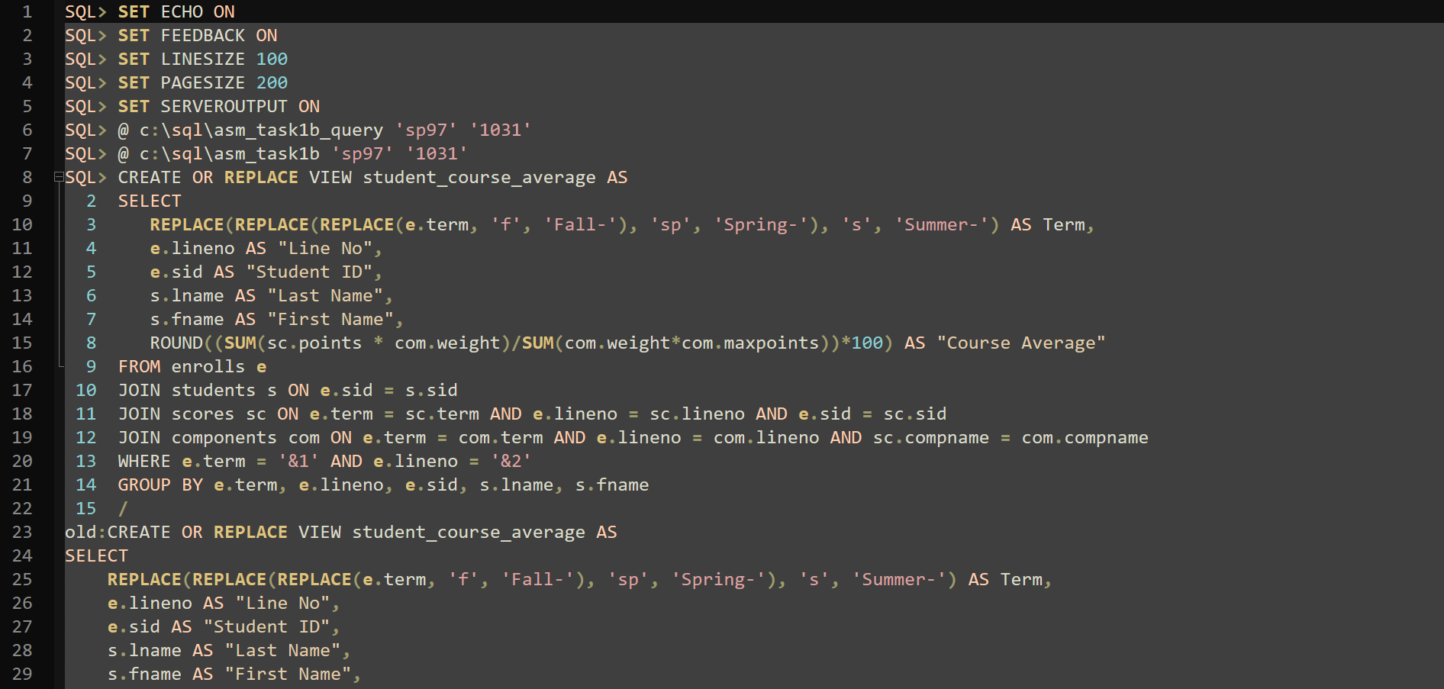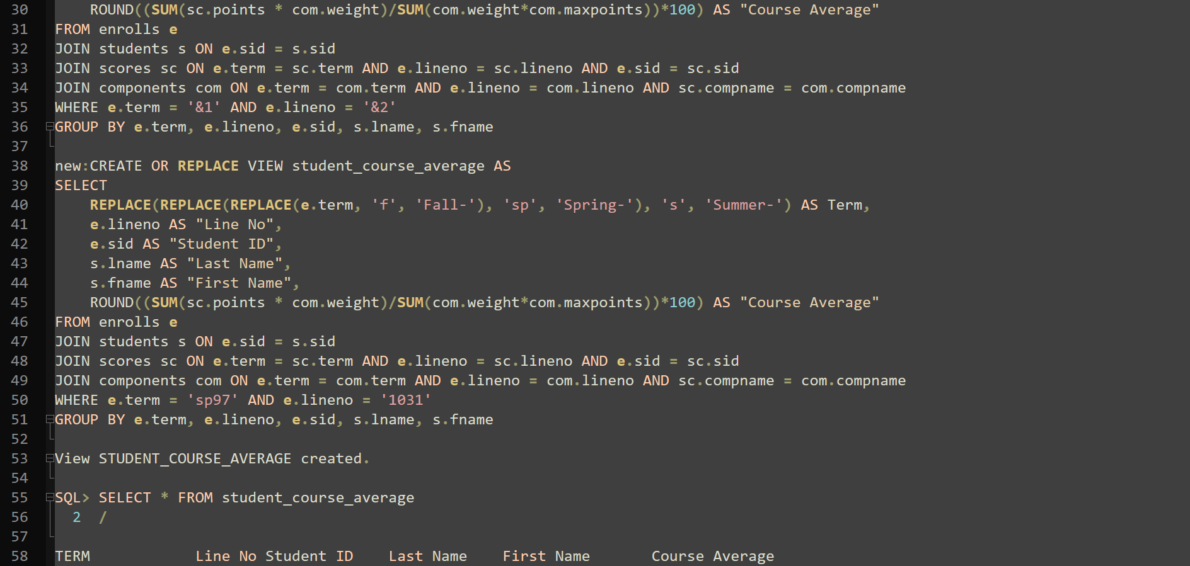

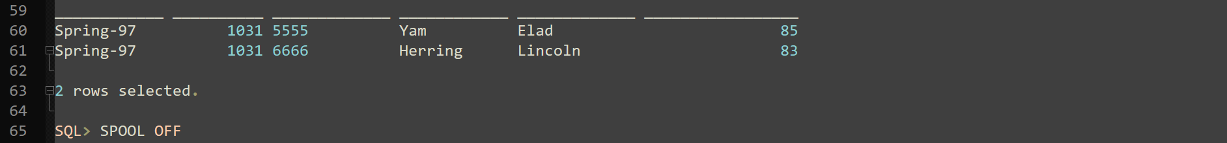

*Figure 3.2* All Statements Processed of Task 1(b)

## 3.3 Task 2

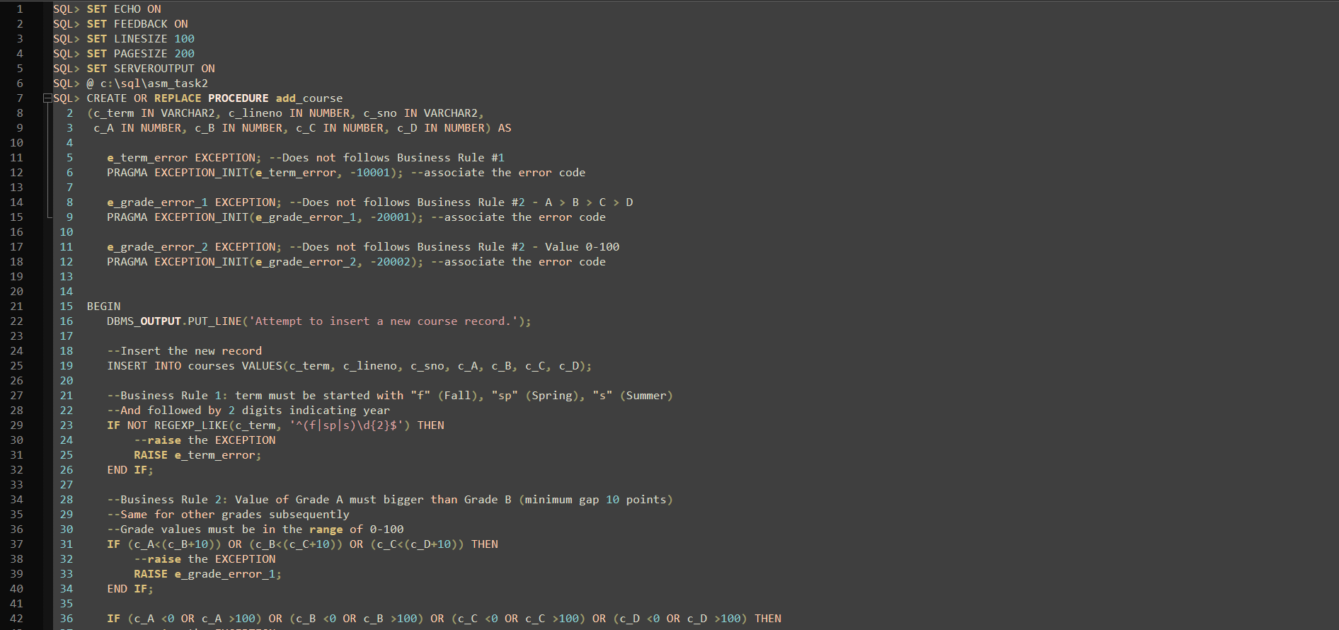

*Figure 3.3* All Statements Processed of Task 2

## 3.4 Screenshots and Test Cases

*Figure 3.4* All Statements Processed of Screenshots and Test Cases

# 4.0 Reference List

Mamalat, G. (2020) *Weighted Average Definition, Formula & Examples - Lesson | Study.com*, *study.com*. Available at: https://study.com/academy/lesson/calculating-weighted-average-method-formula-example.html#:~:text=Simply%2C%20in%20order%20to%20find,equal%20to%201%20or%20100%25. (Accessed: 1 March 2024).

‌